Shelton Community Center Pool
Dress Code

Proper bathing attire required. All patrons entering the pool must have proper swimwear.

There are many types of swimwear available to suit individual tastes and comfort levels. Please be considerate to those around you, as this is a public facility with patrons of all ages.

"Why do I have to wear proper swimwear?"

Street clothes (clothing worn outside of this facility) can transport contaminants and bacteria into the pool, especially cotton clothing.

Lycra and Nylon are the best non-absorbent material for swimming and are the best fabrics for proper swim attire.

- Other absorbent materials (such as cotton) can break down in the water and cause fibers to clog filters.

- Any colored material (unless specifically made for swimming) can bleed into the pool, affecting water chemistry and balance. This is also a reason for turbidity (cloudiness) in pools.

Cotton and similar materials can absorb the chemicals in the water, causing the water to become less effective at maintaining the proper chemical balance or may cloud the water.

Sweat and oils from your body and clothing worn throughout the day react with the Chlorine in the pool leaving less to protect against bacteria and diseases.

Unlike the beach or private backyard pools, Public Pools are required to follow strict Health Codes and must maintain the water quality for the safety of the numerous swimmers that enter the Pool Daily. We easily average 100 to 150 swimmers PER DAY!

When trying to select proper swim attire, ask yourself some of these questions. If you answer “YES” to any of them, it is not proper swim attire for a public pool.

- Would you wear this item to the gym, during other land based sports, or running?
- Is there no netting or liner in your swim trunks/shorts?
- If the item is spandex, would you wear it while participating in a land based sport?
- Is this item purchased in the underwear department, would you wear this item as underwear?
- Is the item intended as a cover-up used while traveling to and from the beach in the summer?
- Is the item made of cotton or any other similar material?
- Would you wear this item for daily activities or errands as a piece of regular clothing?

You will not be allowed to swim and asked to leave if:

- You are not wearing proper swimwear.
- You have been wearing your swimwear for land exercising immediately prior to pool use.
- You have any cotton clothing.
- You are not appropriately covered (no thongs, see through bathing suits, overly loose suits).
Allowed:  - Any clothing designed for swim use that is Chlorine proof and colorfast.  - One piece Bathing Suit  - Two piece Bathing Suit  - Swim shorts  - Swim skirts  - Swimming trunks  - Swim shirt/Rash Guard  - Full swim suit  - Wet suit (must not have been worn outside)  - Water shoes (must not have been worn outside)  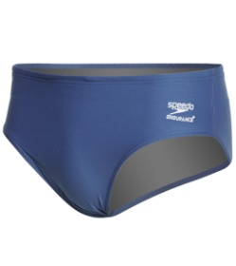  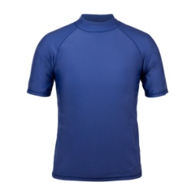  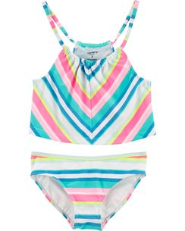  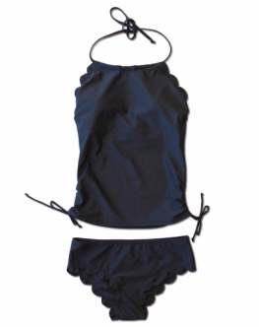  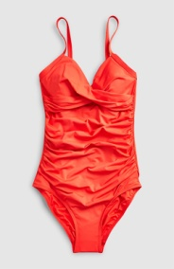  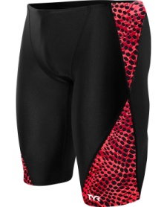  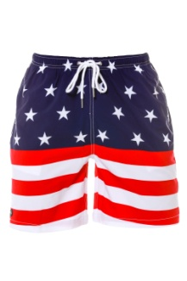 | Not allowed:  - Underwear or Sports bras (including under your suit)  - Cotton clothing  - Gym shorts, basketball shorts, cut-offs, jeans  - T-shirts  - Land Shoes/water shoes or sandals worn from your car to the locker rooms.  - Socks  - Clothing with buttons or zippers  - Any street clothes  - Clothes worn for any activity/exercise prior to entering the pool  - Suits that are see through when wet  - Item bought in the swimwear department that is not a bathing suit (cover-ups, etc).  - Diapers (see pool rules for infant requirements)  